
9

RIVERSIDE PUBLIC UTILITIES

Board Memorandum

▄▄▄▄▄▄▄▄▄▄▄▄▄▄▄▄▄▄▄▄▄▄▄▄▄▄▄▄▄▄▄▄▄▄▄▄▄▄▄▄▄▄▄▄▄▄▄▄▄▄▄▄▄▄▄▄▄▄▄▄▄▄

BOARD OF PUBLIC UTILITIES DATE: JANUARY 27, 2025

SUBJECT: RESOLUTION TO DECLARE AS EXEMPT SURPLUS CITY-OWNED LAND, APPROXIMATELY 8,948 SQUARE FEET, BEARING ASSESSOR’S PARCEL NUMBER 251-040-035, FORMERLY KNOWN AS THE SUGARLOAF BOOSTER STATION, AND AUTHORIZE THE MARKETING AND SALE OF THIS PROPERTY PURSUANT TO ASSEMBLY BILL 1486 AND THE CITY’S ADMINISTRATIVE MANUAL SECTION 08.003.00 FOR THE DISPOSITION AND SALE OF CITY-OWNED REAL PROPERTY

ISSUE:

Consider recommending that City Council adopt a resolution to declare as exempt surplus City-owned land, approximately 8,948 square feet, bearing Accessor’s Parcel Number 251-040-035, formerly known as the Sugarloaf Booster Station, and authorize the marketing and sale of this property pursuant to Assembly Bill 1486 and in accordance with the City’s Administrative Manual Section 08.003.00 for the Disposition and Sale of City-owned Real Property.

RECOMMENDATIONS:

That the Board of Public Utilities recommend that City Council:

- Adopt a Resolution (Attachment 1) to declare as exempt surplus City-owned land, approximately 8,948 square feet, formerly known as the Sugarloaf Booster Station, bearing Assessor’s Parcel Numbers 251-040-035 (Property);

- Authorize the marketing and sale of the Property at fair market value pursuant to Assembly Bill 1486 and in accordance with the City’s Administrative Manual 08.003.00 for the Disposition and Sale of City-owned Real Property; and

- Authorize the City Manager, or his designee, to execute any documents necessary to effectuate this transaction.

BACKGROUND:

Originally enacted in 1968, the Surplus Land Act requires all local agencies to prioritize affordable housing when disposing of surplus land. In 2014, the Surplus Land Act was amended to define what constitutes as a qualified proposal, prioritize proposals to encourage the most housing units at the deepest affordability, and provide more realistic timeframes to make and negotiate offers. On October 9, 2019, State Assembly Bill 1486 (AB 1486) was adopted and required public agencies to notify the State’s Housing and Community Development Department of the availability of surplus land for potential housing development.

On January 9, 2023, the Board of Public Utilities approved Work Order 2116992 for the Sugarloaf Booster Station to Pressure Reducing Station Conversion Project. This project involved replacing the Sugarloaf Booster Station with a new pressure-reducing station.

DISCUSSION:

The Sugarloaf Booster Station was originally built in 1968 and supplied water to the Blaine 1300 Pressure Zone. Of the six pumps that were originally installed, only one remained in operation, and the booster station had experienced several leaks over the years. Many of the components and equipment in this booster station have exhausted their useful service life and are no longer manufactured or available.

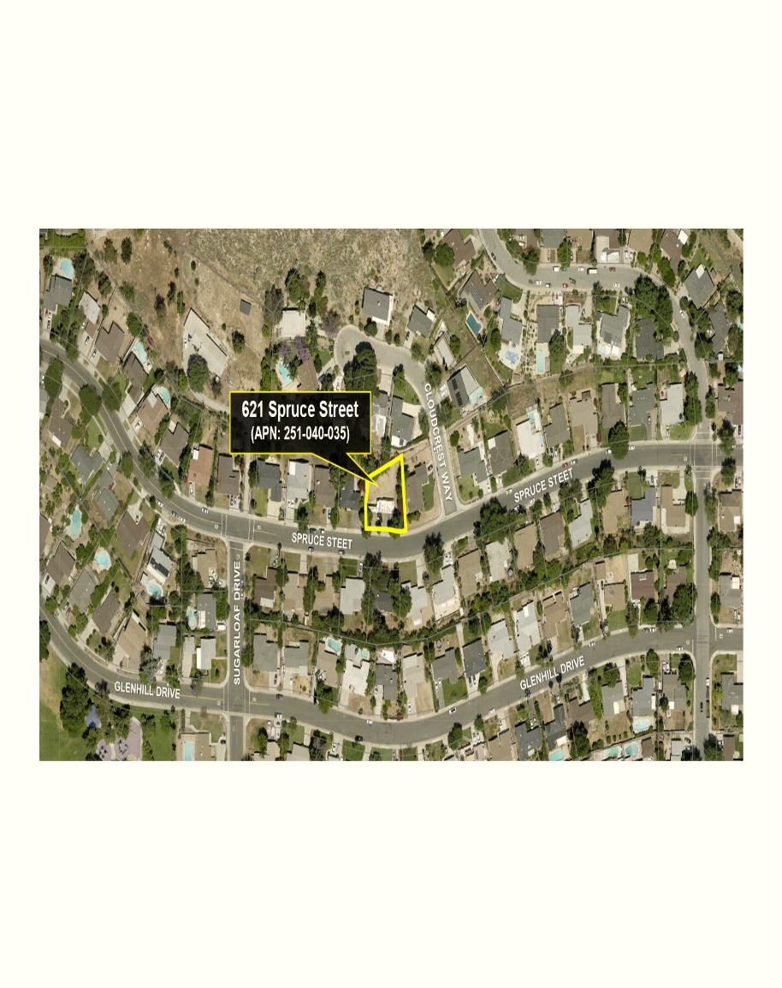
The property contains approximately 8,948 square feet (outlined in yellow below), is zoned R-1-7000 (Single Family Residential) and has a General Plan designation as Residential Medium Density (RMD). The new pressure-reduced station has since been placed in service, and therefore the Sugarloaf Booster Station is no longer needed.

On October 11, 2023, changes to State law were enacted including Senate Bill 747, Government Code Section 54221 (f)(1)(B)(2) which states that a property may be declared “exempt surplus property” if the property is less than one-half acre in area and is not contiguous to land owned by a state or local agency that is used for open-space or low- and moderate-income housing purposes.

Staff confirmed with City’s Housing Authority that the parcel, located in Census Tract 422.14 Block Group 2, qualifies as “exempt” surplus. Upon preliminary review, Housing and Community Development (HCD), also confirmed the parcel fits the “exempt” surplus criteria. As such, the City is required to follow the guidelines contained in the City Administrative Manual Section Number 08.003.00, “Disposition and Sale of City-Owned Real Property” and will adhere to the requirements of Assembly Bill 1486 and Senate Bill 747.

An appraisal, prepared by an independent third party, concluded to a fair market value of $110,000 for the Property.

Remaining on the Property are a concrete block structure, and two driveway pads specifically built for the booster station. The Property is being sold in its “as is” condition. Additionally, the City will reserve an 843 square foot permanent easement for the new pressure-reducing station.

The basic terms of any future agreement provide for a 120-day escrow period in which the prospective buyer has 45 days to perform their due diligence of reviewing the condition of the Property and any other matters affecting the Property. The prospective buyers will be responsible for all recording fees, document transfer taxes, the cost of buyer’s Title Policy premium, and all fees and costs associated with the escrow.

Also, it will be a requirement for any future buyer to remove or cap off any remaining equipment as required prior to any development.

STRATEGIC PLAN ALIGNMENT:

This item contributes to Strategic Plan Priority No. 5 – High Performing Government, specifically Goal 5.4: Achieving and maintaining financial health by addressing gaps between revenues and expenditures and aligning resources with strategic priorities to yield the greatest impact.

The item also aligns with each of the five Cross-Cutting Threads as follows:

- Community Trust – The City is transparent and makes decisions based on sound policy, inclusive community engagement, involvement of City Boards and Commissions, and timely and reliable information. AB 1486 established guidelines for the disposition of all City property that serves the public interest, benefits the City’s diverse population, and results in the greater public good.

- Equity – The City is supportive of racial, ethnic, religious, sexual orientation, identity, geographic, and other attributes of diversity and is committed to advancing the fairness of treatment, recognition of rights, and equitable distribution of services. AB 1486 may require notification of public agencies and affordable housing developers; this ensures the surplus process is continuously fair and equitable.

- Fiscal Responsibility – The City is a prudent steward of public funds. The Surplus Land Act ensures the responsible management and disposition of the City’s financial resources in a manner consistent with the prudent stewardship of public funds while facilitating beneficial investment in the City of Riverside.

- Innovation – The City is inventive and timely in meeting the community’s changing needs. Direction from the Board of Public Utilities and City Council to move forward with the disposition and sale of the Property is consistent with the community’s changing needs and prepares for the future through adaptive processes.

- Sustainability & Resiliency – The City is committed to meeting the needs of the present without compromising the needs of the future. The Surplus Land Act sets standards for the disposition of property that encourages equitable housing solutions to meet the needs of the future and ensures the City’s capacity to preserve, adapt and grow.

FISCAL IMPACT:

The total fiscal impact is estimated to be $110,000 in revenue, less any closing costs (title, escrow and miscellaneous closing costs) of approximately $5,000. The net proceeds from the sale will be deposited into the Riverside Public Utilities Land & Buildings Revenue Account No. 0000520-380010.

Prepared by: Ron Duran, Real Property Agent
Approved by: David A. Garcia, Utilities General Manager
Certified as to
availability of funds: Kristie Thomas, Finance Director/Assistant Chief Financial Officer Approved by: Mike Futrell, City Manager
Approved as to form: Jack Lui, Interim City Attorney

Attachments:
- Resolution
- Presentation

RD:
11/06/2024
/tmp/in/input.doc

