

City Council Memorandum

TO: HONORABLE MAYOR AND CITY COUNCIL DATE: JANUARY 28, 2025

FROM: PUBLIC WORKS DEPARTMENT WARD: 5

SUBJECT: APPROVE A PROFESSIONAL CONSULTANT SERVICES AGREEMENT WITH PROACTIVE ENGINEERING CONSULTANTS, INC., DBA PRINCIPAL OF Q3 CONSULTING OF CORONA, CALIFORNIA, FOR THE DESIGN OF THE MONROE MDP STORM DRAIN CHANNEL STAGE-5 PROJECT IN THE AMOUNT OF $395,875 FOR A TERM OF TWO (2) YEARS THROUGH DECEMBER 31, 2026, WITH AN OPTION TO EXTEND FOR AN ADDITIONAL SIX-MONTHS IN ACCORDANCE WITH RFP NO. 2067

ISSUE:

Approve a Professional Consultant Services Agreement with Proactive Engineering Consultants, Inc., dba Principal of Q3 Consulting of Corona, California, for the Design of the Monroe MDP Storm Drain Channel Stage-5 Project in the amount of $395,875 for a term of two (2) years through December 31, 2026, with an option to extend for an additional six-months in accordance with RFP No. 2067.

RECOMMENDATIONS:

That the City Council:

- Approve a Professional Consultant Services Agreement with Proactive Engineering Consultants, Inc., dba Principal of Q3 Consulting of Corona, California, for the Design of the Monroe MDP Storm Drain Channel Stage-5 Project in the amount of $395,875 for a term of two (2) years through December 31, 2026, with an option to extend for an additional six-month period in accordance with RFP No. 2067; and

- Authorize the City Manager, or designee, to execute the Professional Consultant Services Agreement with Proactive Engineering Consultants, Inc., dba Principal of Q3 Consulting, including making minor and non-substantive changes.

BACKGROUND:

The Project site is located on Monticello Avenue between California Avenue and Colorado Avenue (Attachment 1). The channel within the project limits will be upgraded to increase its capacity and convey a 10-year storm event while providing a higher level of flood protection to the surrounding areas. Selecting a design storm event helps to appropriately size stormwater facilities; 10-year storm is the largest storm with a one in ten chance of occurrence during a ten-year period, larger storms may occur but have a reduced probability of manifesting. The upgrade will consist of removing approximately 3,400 lineal feet of existing concrete lined channel and replacing it with an underground reinforced concrete box. Converting the open channel to an underground box will not only help improve conveyance of stormwater but has the incidental benefits of providing a new trail amenity to residents and reducing debris and vector control concerns in the neighborhood. The already covered portion of the Monroe channel to the south was a successful project welcomed by the community.

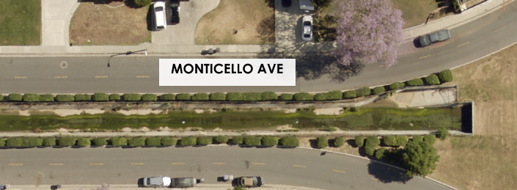
Figure 1: Monticello Avenue Uncovered Channel
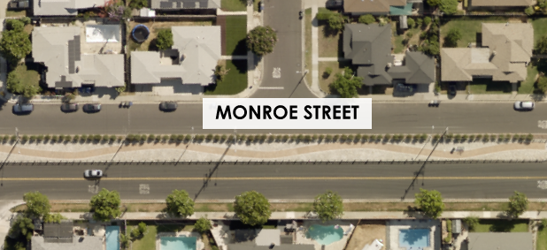
Figure 2: Completed Section of Monroe Covered Channel

DISCUSSION:

On July 24, 2024, RFP No. 2067 for the design of Monroe MDP Storm Drain Channel Stage-5 was posted on PlanetBids to remove approximately 3,400 lineal feet of existing concrete lined channel and replace it with an underground reinforced concrete box under Monticello Avenue. The proposed upgrades will then tie into the existing concrete lined channel after Colorado Avenue. Prior to RFP opening, there were 22 questions received and answered, and one (1) addendum was issued. The RFP notification is summarized in the following table:

Table 1 – RFP No. 2067 - Vendor Notification Summary
Action | Number of Vendors
Vendors Notified | 1,322
Vendors Who Downloaded RFP No. 2067 | 68
Questions and Answers Received | 22
Addenda Submitted | 1
Proposals Received | 7

On August 21, 2024, a total of seven (7) proposals were received for the design of the project (Attachment 2). Staff evaluated the proposals based on the evaluation criteria stated in the RFP, including consultant’s qualifications, approach and methodology, pricing, experience with projects of similar size and scope, and professional references. As a result, Proactive Engineering Consultants dba Principal of Q3 Consulting’s proposal ranked the highest among the proposers.

Table 2 – Proposal Ranking
Proposer | City Location | Rank
Proactive Engineering Consultants | Corona | 1
Engineering Resources of Southern California, Inc. | Redlands | 2
Huitt-Zollars | Ontario | 3
Pacific Advanced Civil Engineering, Inc. | Fountain Valley | 4
Albert A. Webb Associates | Riverside | 5
TKE Engineering | Riverside | 6
*J. Smith & T. Muli, Inc. | San Juan Capistrano | 7
*Proposer was deemed unresponsive due to experience, reference and insurance documentation requirement.

Purchasing Resolution 24101, Article Five, Section 508 states, “Contracts procured through Formal Procurement shall be awarded by the Awarding Entity to the Lowest Responsive and Responsible Bidder, except that…(c) Contracts procured through Formal Procurement for Services or Professional Services, where a Request for Proposals or Request for Qualifications was used to solicit Bids, shall be awarded by the Awarding Entity in accordance with the evaluation criteria set forth in the Request for Proposals or Request for Qualifications”.

The Purchasing Manager concurs that the recommended actions comply with Purchasing Resolution 24101, Section 508(c).

STRATEGIC PLAN ALIGNMENT:

This Project contributes to Strategic Priority 6 – Infrastructure, Mobility and Connectivity and Goal 6.2 – Maintain, protect, and improve assets and infrastructure within the City’s built environment to ensure and enhance reliability, resiliency, sustainability, and facilitate connectivity.

It also aligns with each of the Cross-Cutting Threads as follows:

- Community Trust – This Project will replace and enhance the capacity of the existing storm drain system to ensure areas do not flood during rain events.

- Equity – This Project serves the residents by improving and rehabilitating storm drain infrastructure.

- Fiscal Responsibility – This Project was publicly bid, and the contract will be awarded the best qualified company, based on the Request for Proposal (RFP) evaluation criteria.

- Innovation – This project will explore innovative long-term solutions to address flooding issues present in the existing open channel flow.

- Sustainability & Resiliency –This Project utilizes composite manhole lids, precast concrete manhole shafts, and concrete manhole bases, which are considered the most reliable and sustainable in the industry for these applications. The proposed channel conversion will also incorporate walking trails and landscape, allowing residents more access to green space throughout the city.
FISCAL IMPACT:

The fiscal impact of this action is $395,875. Sufficient funds are budgeted and available in the Storm Drain Fund, MDP Monroe Channel Stage 5-SD Project account number 9909800-440309.

Prepared by: Swetaben Patel, Principal Engineer
Approved by: Gilbert Hernandez, Public Works Director
Certified as to
availability of funds: Kristie Thomas, Finance Director/Assistant Chief Financial Officer
Approved by: Kris Martinez, Assistant City Manager
Approved as to form: Jack Liu, Interim City Attorney

Attachments:
- Project Location Map
- RFP Award Recommendation
- Q3 - Agreement

