
C

RIVERSIDE PUBLIC UTILITIES

Board Memorandum

▄▄▄▄▄▄▄▄▄▄▄▄▄▄▄▄▄▄▄▄▄▄▄▄▄▄▄▄▄▄▄▄▄▄▄▄▄▄▄▄▄▄▄▄▄▄▄▄▄▄▄▄▄▄▄▄▄▄▄▄

BOARD OF PUBLIC UTILITIES DATE: JANUARY 27, 2025

SUBJECT: SERVICES AGREEMENT WITH AIR TREATMENT CORPORTATION OF SAN DIEGO, CALIFORNIA FROM REQUEST FOR PROPOSAL NO. 2412, TO PERFORM COOLING TOWER MAINTENANCE AT THE CLEARWATER POWER PLANT IN THE AMOUNT OF $514,899.69.

ISSUE:

Consider approving a Services Agreement with Air Treatment Corporation of San Diego, California from Request for Proposal No. 2412, to perform cooling tower maintenance at the Clearwater Power Plant in the amount of $514,899.69.

RECOMMENDATIONS:

That the Board of Public Utilities:

- Approve a Services Agreement with Air Treatment Corporation of San Diego, California from Request for Proposal No. 2412, to perform cooling tower maintenance at the Clearwater Power Plant in the amount of $514,899.69; and

- Authorize the City Manager, or his designee, to execute the Services Agreement with Air Treatment Corporation, including making non-substantive changes.

BACKGROUND:

The Clearwater Power Plant (Clearwater) was originally commissioned in 2005 and was acquired by Riverside Public Utilities in September 2010. Clearwater is a combined cycle power plant that uses both a gas and steam turbine together to produce electricity. The waste heat from the 22-megawatt gas turbine is captured and sent to the steam turbine to generate an additional 8-megawatts of electricity without requiring additional fuel. In total, Clearwater produces 30 megawatts of efficient power.

A crucial component of the waste heat steam system is the cooling tower. It cools steam generated from waste heat and condenses it back to water, allowing for it to be recycled in the steam generation process. The condensing process maximizes electric power output and enables the recovery of 95% of the steam.

The cooling tower at Clearwater is shown in the following images:
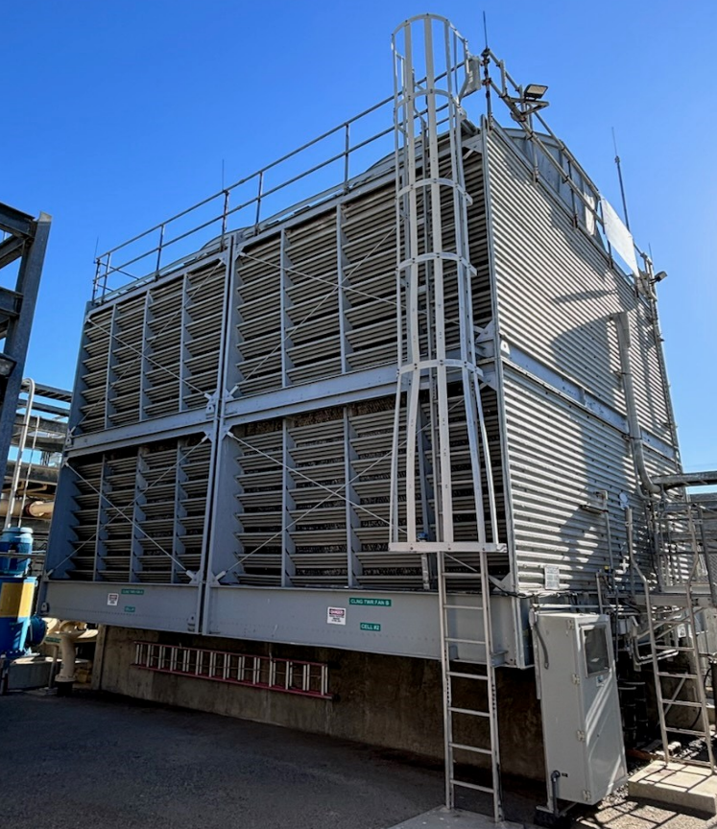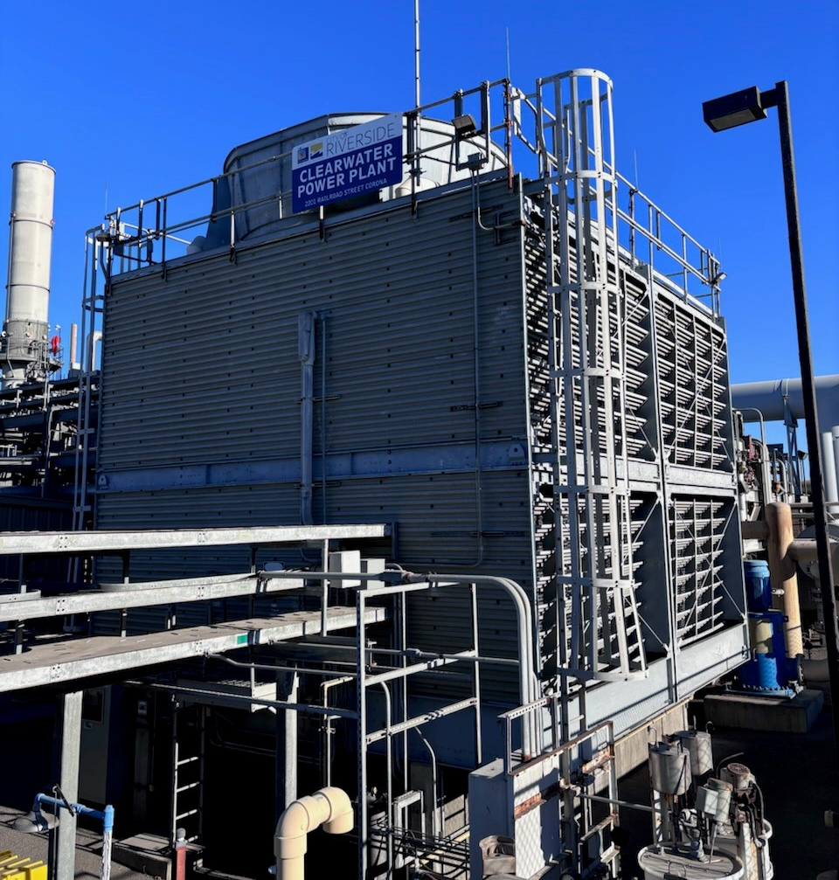

The design of the cooling tower relies on water, airflow, and evaporation to dissipate heat. Hot water from the condenser is evenly distributed over the fill media, where it flows down into the cold-water basin. As the water trickles down, it is cooled by the airflow induced by large fans at the top of the tower, which draw in cool air and expel warm air. The cooled water then collects in a basin at the bottom of the tower, where it is pumped back into the condenser and other plant systems for reuse.

Below is an image of the cooling tower process:

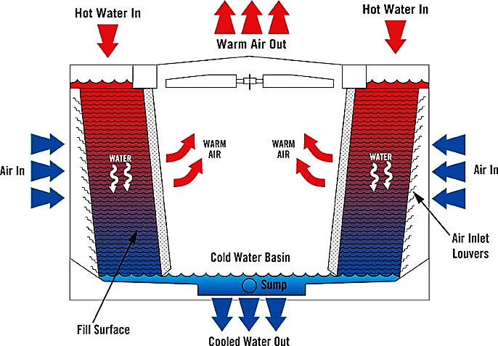

Due to the internal environment of the cooling tower, corrosion prevention and regular monitoring are crucial. A recent inspection resulted in the recommendation to perform required maintenance on worn parts and reapply protective coatings to address sections of corrosion on the cooling tower structure.

Continuing to operate long term without addressing the worn components and corrosion can result in major damage, costly repairs, as well as have an environmental impact. Having been in operation since 2005, this major maintenance interval is needed to ensure the plant operates reliably until its scheduled retirement in 2040.

DISCUSSION:

On September 5, 2024, the City’s Purchasing Division, on behalf of Riverside Public Utilities (RPU), posted Request for Proposal (RFP) No. 2412 on PlanetBids for a qualified vendor to perform necessary maintenance on the cooling tower at Clearwater. The notification summary is shown in the following table:

Table 1. RFP Notification Summary
Action | Number of Vendors
External Vendors Notified | 500
City of Riverside Vendors Notified | 132
Vendors Who Downloaded the RFP | 31
Proposals Received | 3

On September 18, 2024, a mandatory pre-proposal meeting was held, in which representatives from eight companies attended. A total of four questions were received, and one addendum was posted.

On October 16, 2024, three proposals were received in response to RFP No. 2412 and the results are summarized in Table 2 below:

Table 2. Proposal Summary
Vendor | Location | Total | Rank
Air Treatment Corporation | San Diego, CA | $514,899.69 | 1
American Cooling Tower, Inc. | Santa Ana, CA | $612,092 | 2
Energy Options, Inc. | Paramount, CA | $559,935 | 3

RPU staff evaluated the three proposals based on the following criteria:

- Pricing (35% - 35 points)
- Approach and Methodology (35% - 35 points)
- Experience, Qualifications, and Professional References (30% - 30 points)

Air Treatment Corporation was the highest rated proposal and provided the lowest pricing. They are the original equipment manufacturer, and the scope of their proposal included additional recommended maintenance items that the other proposals did not.

Purchasing Resolution 24101 Section 508(c) states, “Contract procured through Formal Procurement shall be awarded by the Awarding Entity to the Lowest Responsive and Responsible Bidder, except that…(c) Contracts procured through Formal Procurement for Services or Professional Services, where a Request for Proposals or Request for Qualifications was used to solicit Bids, shall be awarded by the Awarding Entity in accordance with the evaluation criteria set forth in the Request for Proposals or Request for Qualifications…”

The Purchasing Manager concurs that the recommended actions are in compliance with Purchasing Resolution No. 24101

STRATEGIC PLAN ALIGNMENT:

This item contributes to the following strategic priorities and goals from the Envision Riverside 2025 Strategic Plan:

Strategic Priority 5, High Performing Government
Goal 5.4. Achieve and maintain financial health by addressing gaps between revenues and expenditures and aligning resources with strategic priorities to yield the greatest impact.

Strategic Priority 6, Infrastructure, Mobility & Connectivity
Goal 6.2. Maintain, protect, and improve assets and infrastructure within the City’s built environment to ensure and enhance reliability, resiliency, sustainability, and facilitate connectivity.

The item aligns with EACH of the five cross-cutting threads as follows:

- Community Trust – Ensuring that Clearwater operates reliably during critical periods and provides electricity to RPU’s electric customers serves the greater public good.

- Equity – This item ensures that Clearwater can safely and effectively operate and provide reliable electricity benefiting the entire City and all customers.

- Fiscal Responsibility – Riverside is a prudent steward of public funds and ensures responsible management of the City’s financial resources while providing quality public services to all. This project was competitively bid and the best proposal with the lowest cost was selected.

- Innovation – Performing the recommended maintenance on the Clearwater cooling tower is the best practice and ensures it will continue to operate with high reliability.

- Sustainability & Resiliency – Clearwater must operate during the most critical times of the year when the demand for electricity is high. Performing the cooling tower maintenance prevents the potential of a catastrophic failure and supports the goal of sustaining highly reliable power plant operations.

FISCAL IMPACT:

The total fiscal impact is $514,899.69. Sufficient funds are available in Public Utilities Clearwater Generating Plant Maintenance Account No. 6120140-424131.

Prepared by: Scott M. Lesch, Utilities Assistant General Manager/Power Resources
Approved by: David A. Garcia, Utilities General Manager
Certified as to
availability of funds: Kristie Thomas, Finance Director/Assistant Chief Financial Officer Approved by: Rafael Guzman, Assistant City Manager
Approved as to form: Jack Liu, Interim City Attorney

Attachments:
- Services Agreement with Air Treatment Corporation
- Award Recommendation
- Presentation

