PRESENT: Chair Gibbs, Alderette, Gamblin, Trigueros, Flores

ABSENT: None

STAFF PRESENT: Daniel Prather, Maria Russey.

The Airport Commission convened the meeting at 3:03 p.m.

Pledge of Allegiance

Roll Call

A motion was made by Commissioner Gamblin to nominate Commissioner Gibbs to Chair of the Airport Commission. Commissioner Gibbs made a motion to nominate Commissioner Gamblin as Vice-Chair of the Airport Commission.

The Commission unanimously approved item 1 with no discussion.

ORAL COMMUNICATIONS FROM THE AUDIENCE
There was no one wishing to address the Commission.

CONSENT CALENDAR

MINUTES

ABSENCES

A motion was made by Commissioner Alderette and second by Commissioner Gamblin to approve the Consent Calendar as presented. The Commission unanimously approved item 3 with no discussion.

DISCUSSION CALENDAR

March 2025 Airport Manager’s Operations and Activity Report-Dr. Daniel Prather/Airport Manager.

Airport Manager Daniel Prather began his report by updating the Commission on airport operations and financial statistics.

Following discussion and without formal motion, the Commission received and ordered the file of the March Airport Manager’s Operations and Activity Report.

COMMUNICATIONS

UPDATES OF CONFERENCES, SEMINARS, AND REGIONAL MEETINGS ATTENDED BY
COMMISSIONERS
Commissioner Gamblin presented the 2025 Airport Commission Workplan to the Mobility and Infrastructure Committee on March 13, 2025.

ITEMS FOR FUTURE CONSIDERATION
Commissioner Alderette would like Ohmio to give a presentation at a future Airport Commission meeting.

The Airport Commission adjourned at 3:36 p.m.

Respectfully submitted,

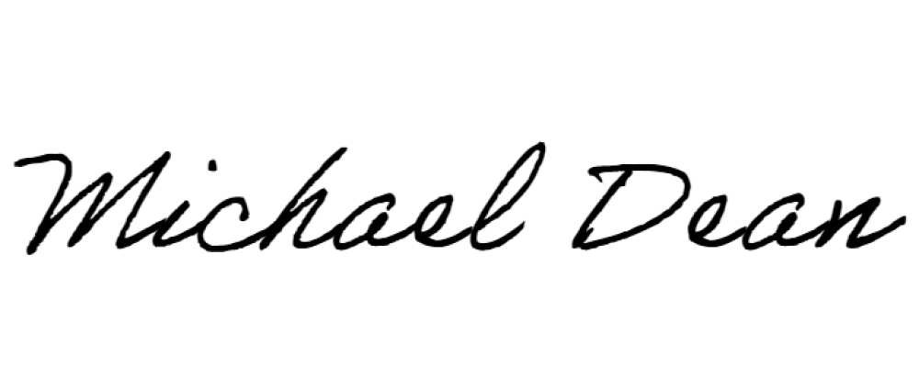
_______________________________
MICHAEL DEAN
Airport Operations Analyst

