PRESENT: Chair Gibbs, Co-Chair Randleman, Commissioners Gamblin, Lightfeldt, and Bloch.

ABSENT: Commissioner Greene and Vazquez.
STAFF PRESENT: Carl Carey, Daniel Prather and Michael Dean

The Airport Commission convened the meeting at 3:02 p.m. Pledge of Allegiance
Roll Call

ORAL COMMUNICATIONS FROM THE AUDIENCE
There was no one wishing to address the Commission.

CONSENT CALENDAR

MINUTES
The minutes of the March 14, 2024, meeting was approved as presented.

ABSENCES
The unexcused absence of Commissioner Greene were approved as presented.

DISCUSSION CALENDAR
March Airport Manager’s Operations and Activity Report-Dr. Daniel Prather/Airport Manager

Co-Chair Randleman asked for clarification on the number of responses presented on the Tenant Survey presentation. Commissioner Gamblin inquired about the dissatisfied response to the openness to the Airport Manager’s Openness to Ideas/Suggestions and

the Response to Inquiries/Emails/Calls on the Teant Survey. Commissioner Lightfeldt asked if comments were allowed on the Tenant Survey.

Following discussion and without formal motion, the Commission received and ordered filed the April Airport Manager’s Operations and Activity Report.

COMMUNICATIONS
UPDATES OF CONFERENCES, SEMINARS, AND REGIONAL MEETINGS ATTENDED BY COMMISSIONERS
Commissioner Gamblin thanked airport staff for the tour of the airport on February 22nd.

ITEMS FOR FUTURE CONSIDERATION
No items for future consideration at this time. The Airport Commission adjourned at 3:39 p.m.
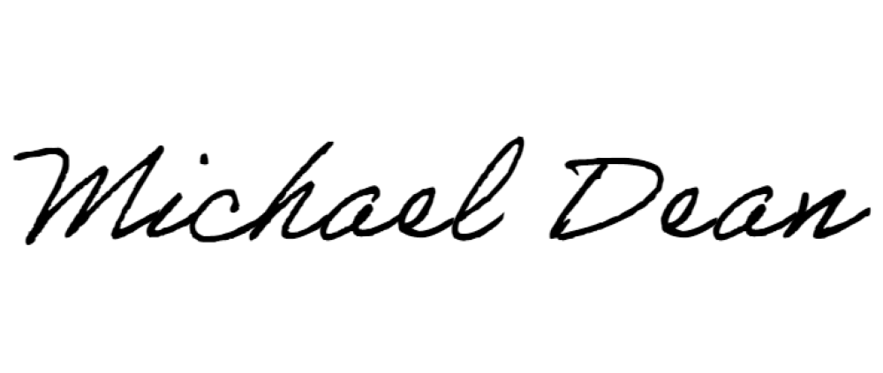
Respectfully submitted,

MICHAEL DEAN
Airport Operations Coordinator

