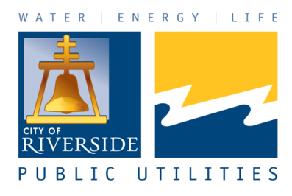

RIVERSIDE PUBLIC UTILITIES

Board Memorandum

▄▄▄▄▄▄▄▄▄▄▄▄▄▄▄▄▄▄▄▄▄▄▄▄▄▄▄▄▄▄▄▄▄▄▄▄▄▄▄▄▄▄▄▄▄▄▄▄▄▄▄▄▄▄▄▄▄▄▄▄▄▄

BOARD OF PUBLIC UTILITIES DATE: JANUARY 27, 2025

SUBJECT: RESOURCE ADEQUACY PURCHASE AND FINANCIAL ENERGY SETTLEMENT AGREEMENT WITH BALDY MESA C, LLC FOR 50 MEGAWATTS OF BATTERY ENERGY STORAGE CAPACITY FROM THE BALDY MESA C FACILITY FOR A TERM OF FIFTEEN YEARS AND AN ESTIMATED INITIAL ANNUAL NET CAPACITY COST OF $4,800,000

ISSUE:

Consider recommending that the City Council approve the Resource Adequacy Purchase and Financial Energy Settlement Agreement with Baldy Mesa C, LLC for 50 megawatts of battery energy storage capacity from the Baldy Mesa C facility for a term of fifteen years and an estimated initial annual net capacity cost of $4,800,000.

RECOMMENDATIONS:

That the Board of Public Utilities recommend that the City Council:

- Approve the Resource Adequacy Purchase and Financial Energy Settlement Agreement with Baldy Mesa C, LLC for 50 megawatts of battery energy storage capacity from the Baldy Mesa C Facility for a term of fifteen years and an estimated initial annual net capacity cost of $4,800,000; and

- Authorize the City Manager, or designee, to execute the Resource Adequacy Purchase and Financial Energy Settlement Agreement and all documents necessary to administer the Agreement including the ability to make non-substantive changes, as well as to execute future amendments to the Resource Adequacy and Financial Energy Settlement Agreement under terms and conditions substantially similar or superior to the Resource Adequacy Purchase and Financial Energy Settlement Agreement or, if needed, to terminate the Resource Adequacy Purchase and Financial Energy Settlement Agreement in accordance with Agreement terms and conditions.

BACKGROUND:

Resource Adequacy (RA) describes an electric utility’s procurement of sufficient power supply capacity to serve its customers’ projected electricity requirements plus an additional amount to be held in reserve for unanticipated circumstances (e.g., unplanned transmission or generation outages.) This additional amount is referred to as a Planning Reserve Margin (PRM).

Section 40 of the California Independent System Operator (CAISO) tariff governs the RA program requirements for load-serving entities (such as Riverside) participating in CAISO markets. The CAISO tariff provides an option for local regulatory authorities of publicly owned utilities to adopt their own PRM and RA Program guidelines that meet certain criteria.

On May 23, 2006, the City Council adopted Resolution 21170, establishing its own RA Program in response to the CAISO Tariff requirements. This action preserved Riverside’s local control over its resource procurement.

On June 5, 2012, the City Council adopted Resolution No. 22389, approving a revised RA Program, which reflected current grid operational conditions, deleted obsolete provisions, and ensured efficient implementation while enhancing reliability.

On August 18, 2020, the City Council adopted Resolution No. 23617, approving specific revisions to the City’s RA Program to eliminate provisions that were no longer applicable and to better facilitate the ability to acquire less expensive RA resources. Resolution No. 23617 specifies that Riverside Public Utilities (RPU) shall maintain at least 15% PRM and be able to demonstrate that the utility has acquired enough System, Local, and Flexible RA to meet all CAISO annual and monthly RA filing deadlines.

DISCUSSION:

Historically, RPU has met most of its annual and monthly RA requirements by purchasing the capacity attributes from generation resources under long-term power purchase agreements (PPAs) with the City. This strategy has typically worked fine for meeting monthly RA requirements during the winter since Riverside rarely exhibits a peak load more than 300 MW from November through March. However, RPU typically needs to buy some additional merchant RA for non-winter months, with most of this need occurring during July, August, and September – which will also be impacted by Riverside’s exit from the baseload Intermountain Power Project in June 2027. Additionally, this need has grown over time as the utility has contracted for more variable renewable wind and solar resources because these variable resources do not provide the same amounts of qualifying RA as either firm baseload resources, dispatchable natural gas generation assets, or dispatchable battery energy storage (BES) assets like those shown in Figure 1 below.

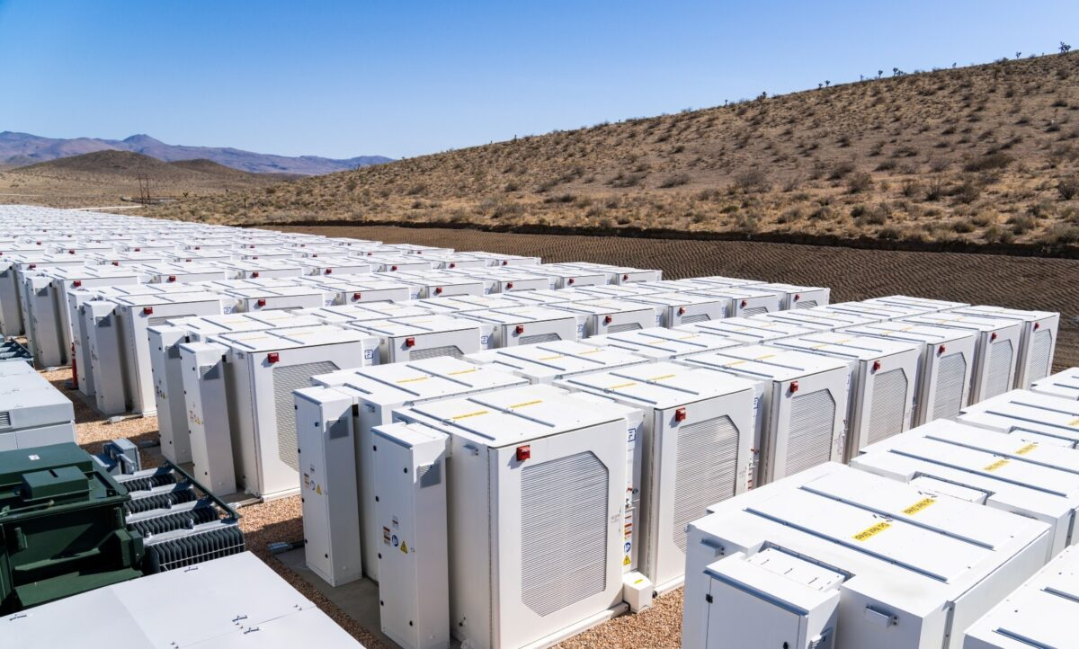
Figure 1. Fluence Energy* Battery Storage Facility
*Siemens and AES Company

Unfortunately, as the state of California has begun more aggressively retiring older natural gas generation assets, a supply shortage of available merchant RA has developed. Since 2019, merchant RA market prices have reflected increasingly volatile year-over-year price increases. Table 1 shows the average cost of RA in the summer months since 2019, as reported by Southern California Publicly Owned Utilities in a recent California Energy Commission (CEC) RA proceeding. Figure 2 shows the corresponding average annual cost of RA graphically for the same period.

Table 1. Average System RA Cost for Q3 (July, August, and September) since 2019.
Year | Q3 Marks – System RA ($/kW-month)
2019 | Under $10.00
2020 | $10.00-$15.00
2021 | $15.00-$20.00
2022 | $20.00-$40.00
2023 | $35.00-$55.00
2024 | $65.00-$100.00

Figure 2. Average Annual RA Cost since 2019.

Additionally, RPU staff have witnessed these same increasing RA cost pressures firsthand in the merchant responses to Market Operations RA Requests for Offers (RFOs). In 2022, the average calendar year offer price for RA received in seven responsive RFOs was $6.65/kW-month. In 2023, the average calendar year offer price for RA received in four responsive RFOs increased to $13.06/kW-month. In 2024, staff received only two responsive offers for calendar year RA, at an average price of $35.53/kW-month. The most recent calendar year RA responses for 2026 have averaged $20/kW-month. While the exorbitant price increases are showing signs of stabilizing, staff expect that the California merchant capacity market could continue to be volatile for the next 2-5 years, due to the various BES development bottlenecks currently occurring in the CAISO balancing authority area.

Given RPU’s need for increasing amounts of RA, coupled with the recent increasing RA cost pressures, it is critically important that the Utility negotiate and secure additional long-term, cost-effective RA contracts. Furthermore, considering RPU’s sustainability and carbon reduction goals, staff are pursuing these new contracts with BES facilities rather than natural gas generation assets. On June 10, 2024, and July 2, 2024, the Public Utilities Board and City Council approved a 15-year, Resource Adequacy Purchase and Sale Agreement with Vesi 15, LLC for 80 megawatts (MW) of battery energy storage capacity. That prior Agreement is effectively replacing about 59% of the RA capacity that Riverside will lose due to the impending retirement of the Intermountain Power Project (IPP). This proposed Resource Adequacy Purchase and Energy Settlement Agreement will entitle the Utility to an additional 50 MW / 200 MWh of RA from the Baldy Mesa C facility located in Adelanto, California, in turn allowing the Utility to replace an additional 50 MW (37%) of the retiring IPP RA. Additionally, this new Agreement will also provide the City with a 200 MWh financial hedge against volatile intra-day CAISO energy price deviations.

The proposed Agreement has the following characteristics and favorable terms:

Term of the Resource Adequacy Purchase and Energy Settlement Agreement: A fifteen-year Agreement commencing upon the Commercial Operation Date, anticipated to occur in Spring, 2027. This expected commercial operation date closely aligns with Riverside’s June 2027 exit from the Intermountain Power Project.

Price: The annual levelized price of the full contract is $17.00/kW month. The seasonal capacity price translates to $8.00/kW-month, while the financial energy settlement hedge is priced at $9.00/kw-month and designed to net against the monthly day-ahead (DA) energy settlement revenues.

Monthly Energy Settlement: This agreement has a monthly energy settlement which uses each month’s four highest and five lowest DA index prices to offset the fixed price $9.00/kW-month hedge payment. Staff expect these future monthly settlement revenues to either nearly offset or more likely exceed the monthly hedge payments, effectively lowering the total cost of this agreement.

Guaranteed Commercial Operation Date: The Baldy Mesa C Facility has a guaranteed commercial operation date of March 1, 2027. Failure to achieve commercial operation by March 1, 2027 will result in payment of Daily Liquidated Damages of $30,000 per day. With failure to achieve commercial operation by the Outside Commercial Operation Date of September 1, 2027, Riverside shall have the right to terminate the agreement. However, both the Guaranteed Commercial Operation Date and Outside Commercial Operation Date are based on the expectation that Buyer receives City Council approval no later than January 31, 2025. If Buyer’s City Council approval does not occur by January 31, 2025, then the Milestone Date for the Guaranteed and Outside Commercial Operation Date shall be automatically extended per Table 2 below:

Table 2. Guaranteed and Outside Commercial Operation Dates.

If City Council approval occurs in | Construction Start Date | Guaranteed Commercial Operation Date | Outside Commercial Operation Date
February 2025 | October 1, 2026 | April 1, 2027 | October 1, 2027
March 2025 | November 1, 2026 | May 1, 2027 | November 1, 2027
April 2025 | December 1, 2026 | June 1, 2027 | December 1, 2027
May 2025 | January 1, 2027 | July 1, 2027 | January 1, 2028

Delivered Product: RPU has contracted for all RA attributes from the Baldy Mesa C facility. These attributes include both System RA and Flexible RA benefits.

Resource Adequacy Guarantees: The agreement includes the enforceable guarantee to receive all RA benefits from the Baldy Mesa C Facility throughout the term of the agreement. Failure to deliver these RA benefits could result in the payment of liquidated damages.

Decommissioning Costs: RPU shall have no responsibility or liability for any cost of decommissioning or demolition of the Facility.

Project Development Security: Within ten (10) days of executing this Agreement, Baldy Mesa C, LLC will provide a Project Development Security in the amount of $100/kW of Storage Contract Capacity ($5,000,000 total deposit).
Project Delivery Term Security: Upon achievement of the Commercial Operation Date, Baldy Mesa C LLC will provide a Delivery Term Security in the amount of $120/kW of Installed Battery Capacity ($6,000,000 initial deposit, which may decrease over time as the annual capacity decreases).

Financial Assessment of Contract Value: Since this Agreement encompasses both a RA contract and a financial energy settlement contract, it is helpful to examine the net value of each component separately, as discussed further below.

- Assessment of RA capacity value: On an annual basis, the normalized cost for the RA capacity equates to $8.00/kW-month, fixed for 15 years. (Note that the total cost for the RA capacity will decrease each year, as the total battery capacity level decreases.) In the attached Proforma, this cost has been compared to the expected annual RA capacity value, as reported in RPU’s 2023 Integrated Resource Plan (see chapter 7, table 7.6.1). On an average annual basis, the cost for this RA capacity will be $4.09 million, while the implied value of this RA is expected to be $5.14 million.

- Assessment of Financial Energy hedge for intra-day DA energy price deviations: A careful assessment of the expected value of (and corresponding uncertainty around) the Financial Energy (FE) hedge was carried out by performing 100 in-depth simulations of hourly SP15 day-ahead market energy prices from January 2027 through December 2042. On an annual, normalized basis, the expected revenue from this FE hedge was found to be ~ $11.06/kW-month, with an associated uncertainty of ~ +/- $3.00/kW-month. Figure 3 below shows the simulated annual Mean (average), P5 (5th percentile), and P95 (95th percentile) $/kW-month FE hedge revenues versus the $9.00/kW-month cost for years 2028 through 2041, respectively. As summarized by this plot, a significant majority of simulations (e.g., 80% to > 95%) yielded FE hedge revenues in excess of the contract cost, suggesting that this financial energy settlement should provide for a net positive cash flow to the Utility. Additionally, as shown in the attached Proforma, on an average annual basis the cost for this FE hedge will be $4.60 million, while the revenue from this FE hedge is expected to be about $5.66 million.

Figure 3. Simulated annual Financial Energy hedge revenue (Mean, P5, P95) versus Energy hedge cost ($/kW-month), for years 2028 through 2041.

In addition to examining the simulated FE hedge revenues on an annual basis, staff also studied these results at a monthly granularity. Figure 4 shows the simulated annual Mean (average), P5 (5th percentile), and P95 (95th percentile) $/kW-month FE hedge revenues versus the $9.00/kW-month cost for January 2032 through December 2034. This 3-year monthly time plot, which is fairly typical of the 15-year simulation results, shows that the highest average FE hedge revenues are generally expected to occur during the summer months. These results are intuitively reasonable, since diurnal energy price variations tend to be the most pronounced during the summer (especially during heatwaves).

Figure 4. Simulated monthly Financial Energy hedge revenue (Mean, P5, P95) versus Energy hedge cost ($/kW-month), for years 2032 through 2034.

These simulation results are consistent with the last five years of historical day-ahead CAISO price information for proposed interconnection point of the Baldy Mesa BES facility (SCE Roadway 115 kV substation). Table 3 below shows the annual FE hedge revenue for this interconnection point from 2019 through 2023, expressed on a $/kW-month basis. The historical revenue amounts (that would have been realized had this contract started in 2019) have clearly been increasing over time, in conjunction with the increasing deployment of utility-scale solar PV projects in and around the greater Adelanto area.

Table 3. Top4-Bottom5 annual revenue streams ($/kW-month) for years 2019-2023 at the SCE Roadway interconnection point.

Year | 2019 | 2020 | 2021 | 2022 | 2023
$/kW-month | $4.40 | $6.06 | $6.30 | $8.99 | $8.35

A closer examination of the 2022 monthly FE hedge revenue for this interconnection point is shown in Figure 5. The five monthly payments greater than $9.00 would have resulted in net revenue credits to RPU. The especially large September revenue credit reflects the September 2022 heat wave impacts on CAISO day-ahead energy prices and shows how this type of Financial Energy hedge can help compensate the Utility during such market stressed conditions.

Figure 5. Calculated monthly Financial Energy hedge revenue ($/kW-month), for year 2022 at the SCE Roadway interconnection point.

- Combined assessment of both cost and revenue streams: In summary, staff’s Financial Proforma shows that the fixed $8.00/kW-month RA payment is materially lower than the anticipated annual value of future system RA (anticipated to be $10.06/kW-month, averaged over the entire contract term). Additionally, the simulation assessment of the FE hedge suggests that this instrument should pay out $11.06/kW-month in gross revenue. Thus, after netting this against the fixed $9.00/kW-month hedge cost, the net project cost for the RA from this facility is projected to decrease to $5.94/kW-month. This represents an annual average savings of about $2.11 million in Power Supply capacity costs, when compared to the projected costs the Utility would have to pay to obtain the same amount of system RA on a year-by-year basis.

Per Purchasing Resolution No. 24101, Article Seven: Acquisition of Services, Section 702, Exception which provides that “Competitive Procurement through the informal or formal procurement process shall not be required…(o) “When the Procurement is for wholesale energy, energy ancillary services, energy transmission, wholesale water commodity, and water transmission purchase by or on behalf of the City’s Public Utilities Department.”

The Purchasing Manager concurs that the recommended actions are in compliance with Purchasing Resolution No. 24101, Section 702 (o).

STRATEGIC PLAN ALIGNMENT:

This item aligns with Strategic Priority 2 – Community Well-Being and Goal 2.6 – Strengthen community preparedness for emergencies and disruptive events to ensure effective response and recovery.

This item aligns with EACH of the five Cross-Cutting Threads as follows:

- Community Trust – The RA Agreement is being presented for approval to the Board of Public Utilities and the City Council in an open public process. Staff’s assessment of the risks, benefits, and value of this Agreement includes a transparent financial analysis.

- Equity – This RA Agreement will help RPU ensure that it is meeting its obligation to provide sufficient RA capacity to the CAISO, and thus provide reliable electric service to all RPU customers.

- Fiscal Responsibility – By meeting CAISO RA Obligation requirements, RPU avoids the possibility of incurring CAISO penalties, including “backstop” capacity procurement charges, RA deficiency fines, and/or additional RA uplift costs.

- Innovation – By maximizing the use of existing generating resources and forward procuring additional long-term RA resources, staff are using a cost-effective and innovative approach to ensure that sufficient RA capacity is available to the CAISO grid.

- Sustainability & Resiliency – This RA Agreement will help ensure that RPU is doing its part to assist the CAISO with operating and maintaining a safe and reliable grid.

FISCAL IMPACT:

The initial annual total net cost of capacity under this Resource Adequacy Purchase and Energy Settlement Agreement is estimated to be approximately $4,800,000, with an anticipated guaranteed commercial operation date in Spring 2027. Funding for this project will be included as part of the FY26/27 biennial budget approval process and budgeted in the Public Utilities’ Power Resources Capacity Account No. 6120100-422915.

Prepared by: Scott M. Lesch, Assistant General Manager/Power Resources
Approved by: David A. Garcia, Utilities General Manager
Certified as to
availability of funds: Kristie Thomas, Finance Director/Assistant Chief Financial Officer Approved by: Rafael Guzman, Assistant City Manager
Approved as to form: Jack Liu, Interim City Attorney

Attachments:
- Financial Proforma
- Resource Adequacy Purchase and Energy Settlement Agreement
- Presentation

Each simulation run consisted of 12 x 8,760 + 4 x 8,784 = 140,256 simulated hourly prices.
As reflected in the Net Project Value column shown in the attached Financial Proforma.

