

RIVERSIDE PUBLIC UTILITIES

Board Memorandum

▄▄▄▄▄▄▄▄▄▄▄▄▄▄▄▄▄▄▄▄▄▄▄▄▄▄▄▄▄▄▄▄▄▄▄▄▄▄▄▄▄▄▄▄▄▄▄▄▄▄▄▄▄▄▄▄▄▄▄▄▄▄

BOARD OF PUBLIC UTILITIES DATE: JANUARY 27, 2025

GENERAL MANAGER’S REPORT

SUBJECT: MONTHLY WATER REPORT – November 30, 2024

Total water production (potable and non-potable) was 5,907 acre-feet (AF) or 1,925 million gallons. For reference, an acre-foot is the volume of water needed to cover 1 acre of land with water 1 foot deep. This equates to about 325,850 gallons of water – about half the size of an Olympic swimming pool).
For Fiscal Year 2024-25 to date, total water production and deliveries of 37,311 AF increased by 2,498 AF (7%) from last fiscal year, as shown in Figure 1 of the attachment to this report. Total production by calendar year is shown in Figure 2 (attached). The annual rolling production totals by month are shown in Figure 3 (attached). In November, the peak water usage on the potable water distribution system was 60.5 million gallons per day and occurred on November 8, 2024, as shown in Figure 4 (attached).
November potable water production totaled 5,094 AF, a decrease of 522 AF (9%) from last November. Under its production, conveyance, and emergency water supply agreements, the water division wheeled 0 AF of potable water to the Western Municipal Water District and wholesaled 69 AF of potable water to the City of Norco in November.
In November, RPU’s Gallons Per-Capita per Day (GPCD) was 177, and its Residential Gallons Per-Capita per Day (R-GPCD) was 99. RPU’s annual rolling GPCD was 177, which is below the compliance target specified in SB X7-7 (i.e., 20% reduction by 2020) of 213. RPU’s annual rolling R-GPCD was 101, as shown in Figure 5 (attached). On July 3, 2024, the State Water Resources Control Board adopted the 'Making Conservation a California Way of Life' regulation, which includes new performance standards. These standards are expected to become effective on January 1, 2025.
Weather conditions in the City of Riverside indicate that November 2024 was 3.5 degrees cooler compared to November last year, with a decrease of 0.21 inches in rainfall compared to November 2023.
On a regional scale, the link below provides real-time updates on the progression and intensity of the Drought within the State:
https://droughtmonitor.unl.edu/CurrentMap/StateDroughtMonitor.aspx?CA
The maps below show the drought conditions throughout the State between November 2023 and November 2024, and an annual class change map for improvement or degradation in the drought conditions.

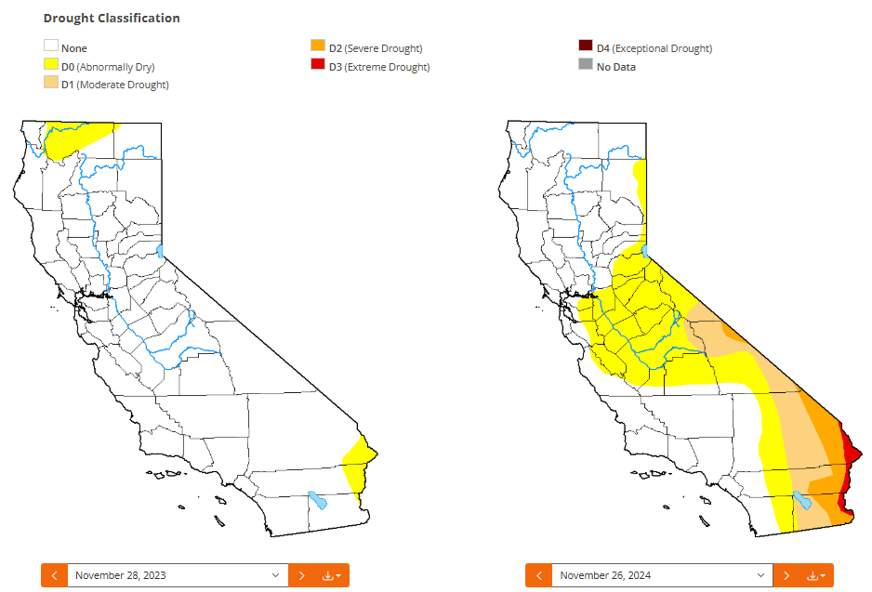
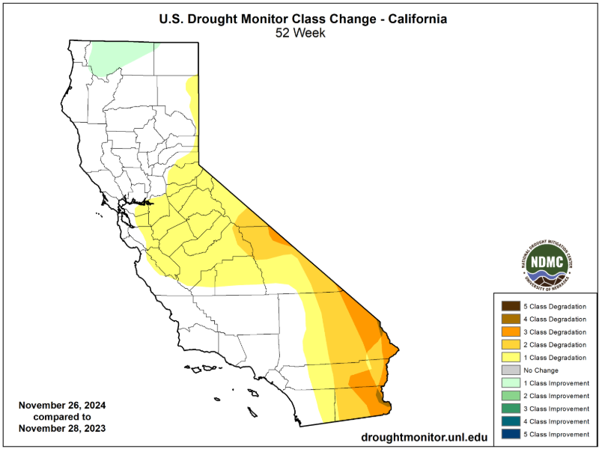
Significant events for the water system in November 2024.

Date | Site | Issue | Comments | Status
Jan-24 | Gage 56-1 | Motor |  | Out of Service
Oct-24 | Hunt 10 | Motor | Replacement | Out of Service
Nov -24 | Scheuer |  | Well Rehab | Out of Service
Nov -24 | Garner B |  | Well Rehab | Out of Service

Basin Groundwater Levels

Groundwater levels in the Bunker Hill, Rialto-Colton, and Riverside North basins continue to show a long-term decline, while groundwater levels in the Riverside South Basin remain relatively stable as described below and shown in Figure 6 (attached).

- Water levels in the Bunker Hill Basin increased by 11 feet compared to November of last year.
- Water levels in the Rialto-Colton Basin increased by 13 feet compared to November of last year.
- Water levels in the Riverside North Basin increased by 6 feet compared to November of last year.
- Water levels in the Riverside South Basin remained relatively unchanged compared to November of last year

Since 1994, RPU has invested in capital improvement projects such as stormwater capture in the Bunker Hill Basin to mitigate declining water levels in its groundwater basins and support Riverside's primary water supply source. These stormwater capture projects will become operational this spring, with full implementation in early spring 2025. The project will have the capacity to capture up to 80,000 AF of stormwater in any wet year, supporting groundwater levels in Riverside's groundwater wells while increasing Riverside's extraction rights as set by the Western-San Bernardino Watermaster.

Water Unit Conversion:
1 million gallons: 3.069 acre-feet.

